

Q1:

Software Requirements Specification

for

Koi Order System

Version 1.0 approved

Prepared by

Vu Van Trong– HE172080

FU – Hoa Lac

Wednesday, July 24

Q2:

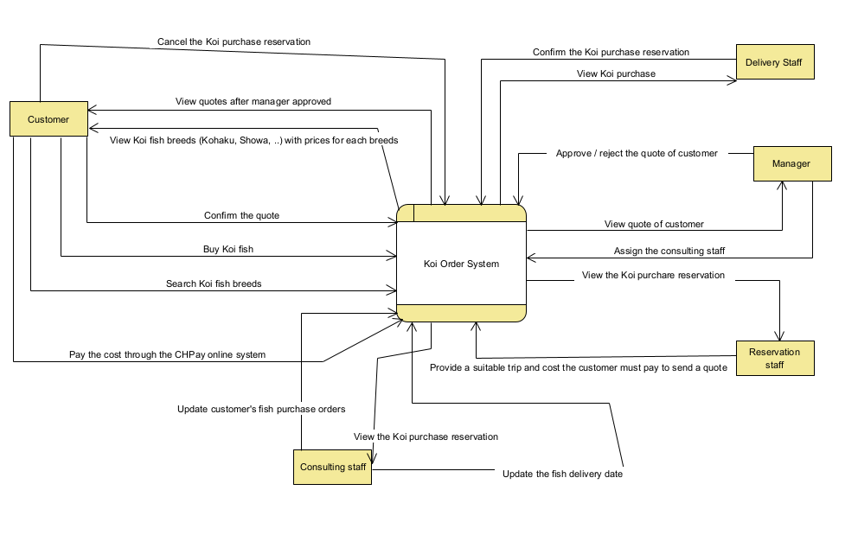

Q3:

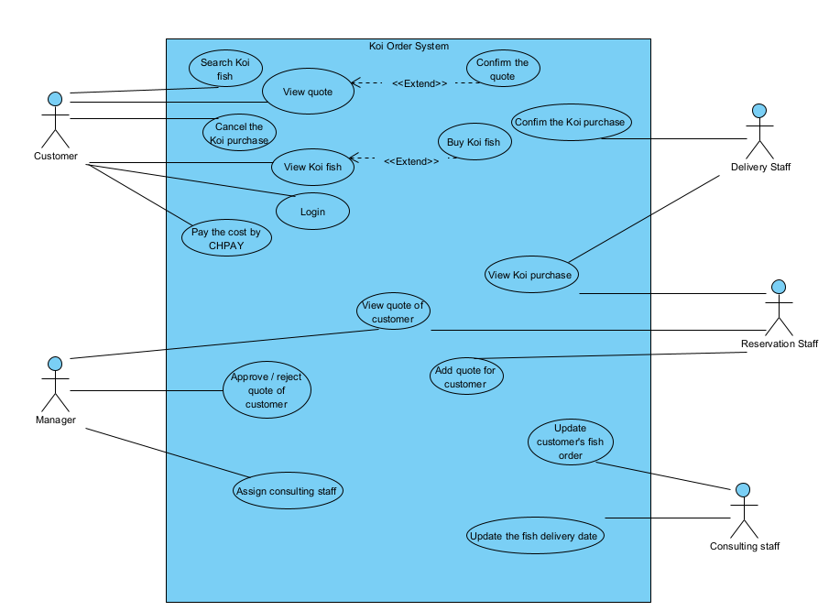

|  |  |  |
| --- | --- | --- |
| **#** | **Actor** | **Description** |
| 01 | Customer | People who search and buy Koi fish by using system. |
| 02 | Manager | Manage quote of the customer |
| 03 | Reservation Staff | Responsible for providing recommends a suitable trip route through the farms and cost the customer must pay to send a quote to the customer |
| 04 | Consulting staff | Responsible take attendance of the customer on the trip and update customer’s fish purchase orders |
| 05 | Delivery staff | Responsible delivering fish to the customer and receiving the customer’s remaining payment. They will confirm the Koi purchase reservation has been delivered |

|  |  |  |  |
| --- | --- | --- | --- |
| **#** | **Use Case** | **Actors** | **Description** |
| UC-01 | Buy Koi fish | Customer | Customer can buy Koi fish at Japanese farms with desired proposals (breeds, farm, ..). |
| UC-02 | Login | Customer | Customer can login through an account registered with the system |
| UC-03 | Cancel the Koi purchase | Customer | Customer can cancel the Koi purchase what they ordered before. |
| UC 04 | Pay the cost by CHPay | Customer | Customer can pay the quote of them by CHPay system |
| UC-05 | View quote | Customer | Customer can view the quote of them. |
| UC-06 | Update customer fish order | Consulting staff | Consulting staff can change information order of customer |

Q4:

|  |  |  |
| --- | --- | --- |
| ID | Rule Definition | Use cases |
| BR-01 | The customer only view quote when manage approved it. | UC-05 |
| BR-02 | Before 48 hours of the trip departure date, the customer can cancel the Koi purchase reservation but will have to pay airfare and hotel fee. | UC-03, UC-04 |
| BR-03 | To be able to order fish, the customer needs to deposit 30% of the value of the fish | UC-01 |
| BR-04 | The customer will lose his deposit when canceling the fish delivery | UC-03 |
| BR-05 | If the amount of money in the wallet is not enough, the customer needs to top up the wallet through the function in the system | UC-04 |

**Q5:**

|  |  |  |
| --- | --- | --- |
| **#** | **State** | **Description** |
| 01 | Approved | The Manage accept the quote of customer request. |
| 02 |  |  |
| 03 |  |  |